Cashion Music Boosters’ Chili Dinner

When: Friday, November 8
Where: Cashion School’s Cafeteria Annex
Time: 5:00pm to 6:30pm
Cost: $10.00 per adult / $5.00 per child (10 and under)
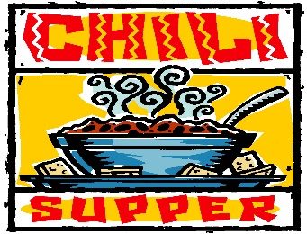
This Photo by Unknown Author is licensed under CC BY-NC
What are we having?
Chili and Desserts
Fixin’s: Fritos, Cornbread, Crackers, Sour Cream, Cheese, Jalapenos, Mustard, Hot sauce
Cashion’s Jazz Band will be playing a few songs while we eat!

*Donations welcome! If you are writing checks for the meal or donations, please make checks payable to Cashion Music Boosters.
**Contact Kim Simmons (Cashion Music Booster President) for more information: ksimmons@cashionps.org

